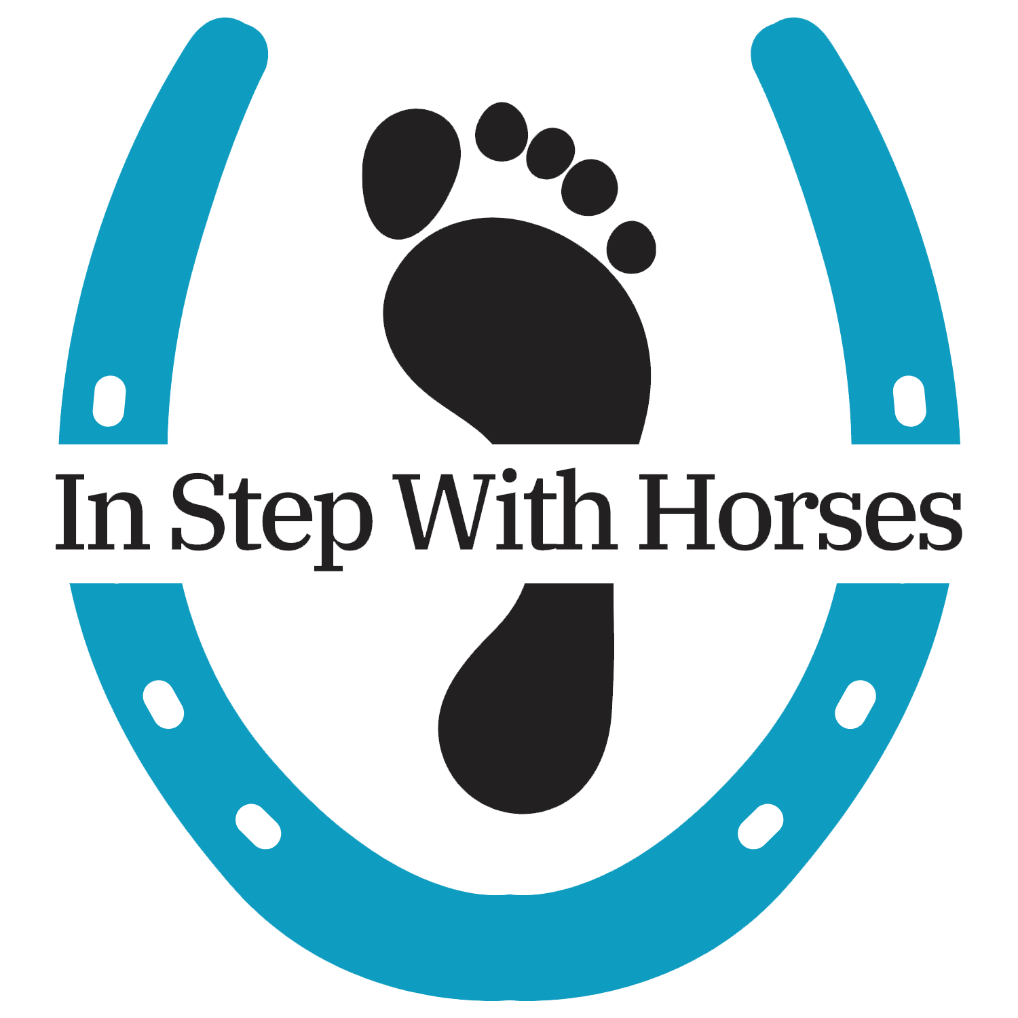

JOB TITLE: Equine Specialist (ES)

JOB DESCRIPTION: The Equine Specialist is responsible for the horse welfare while being included in EAL and EAP programs. This role ensures the physical and emotional well-being of the horses while supporting program staff in facilitating sessions. The Equine Specialist serves as a bridge between horse and human, modeling calm, attentive, and responsive equine interactions that enhance participant learning and therapeutic outcomes.

ACCOUNTABILITY: This position reports to the Clinical Director.

RESPONSIBILITIES INCLUDE (BUT NOT LIMITED TO):
Key Responsibilities:
- Animal Care & Health Management:
  - Monitor horses to ensure suitability for EAL and EAP programming, including desensitization, ground manners, and response to human interaction
  - Monitor horse/animal behavior and health, addressing any concerns in consultation with the barn manager and/or assistant barn manager.

- Program Support:
  - Maintain knowledge of and engage in ongoing training around areas of mental health and trauma to a degree that supports collaboration with therapists/facilitators, being part of the treatment team and assisting with appropriate session structure based on client needs and therapist’s lead.
  - Assist program facilitators/therapists during sessions, including setting up activity areas, preparing horses, and supporting safe horse-participant interactions.
  - Collaborate with program staff to match horses with participants based on temperament, skill level, and program goals.
  - Educate participants and staff about horse behavior, body language, and safe handling practices.

- Safety & Risk Management:
  - Ensure that the barn and surrounding areas are safe for animals and people, adhering to all safety protocols.
  - Support ongoing barn and property maintenance, including arena upkeep, fencing, and equipment care.

- Administrative Tasks:
  - Participate in staff meetings, training, and professional development related to equine care and equine-assisted interventions.
  - Complete any supplemental client notes within 72 hours of each session. Therapist/primary facilitator will be responsible for note when part of the treatment team. Otherwise, notes will be the responsibility of ES for individual EAL sessions.
  - When the ES is the primary staff for a client, the ES will be responsible for creating a treatment plan with goals for the client at the onset of engaging in the EAL program. Treatment plans will be reviewed at minimum every 6 months or if goals are met or need modified before the 6 month mark
Qualifications:
- Extensive knowledge of horse care, handling, and training.
- Experience with horses in therapeutic or educational settings preferred.
- Ability to work independently and collaboratively in a team environment.
- Strong observational skills and attention to safety.
- Excellent communication skills for interaction with staff, participants, and volunteers.
- Physical ability to perform horse care tasks (lifting, bending, prolonged standing).
- Relevant certifications in equine handling, horsemanship, or equine therapy preferred (e.g., Natural Lifemanship, The HERD Institute, PATH Intl., EAGALA).
Work Environment:
- Primarily outdoors in barn, arena, and pasture settings.
- Interaction with a diverse group of participants and volunteers.

EXPECTED HOURS AND COMPENSATION: This is a part-time position. May require early mornings, evenings, or weekend hours based on program schedules. Total weekly hours will vary, but equal not more than 20 hours per week.

ADDITIONAL INFORMATION ABOUT THIS POSITION & ORGANIZATION:
We are a small and nimble organization. Team members wear many hats. In addition to the ES responsibilities, there may be an ask to assist with intermittent animal care as applicable. You will be expected to work independently, meet all timelines and perform all required tasks. We are looking for someone who can take initiative and keep the Clinical Director informed of any issues with clients, the animals, equipment or facility that require additional attention. It is an opportunity for someone who wants to have a career in equine-assisted services. .

